Metreos Installation QuickStart

This guide assumes a one-server Metreos Communications Environment installation. Call Control and Media Server capabilities are all on one server. Also, we assume that the only applications that will be installed on this system are the Metreos Application Suite applications—
- VoiceTunnel
- ActiveRelay
- ScheduledConference
- Click-To-Talk
- RapidRecord
- Intercom

For this demo setup, we will assume that 3 physical IP phones are present. One IP phone will be the same real IP phone we created a shared line appearance with from up above with ActiveRelay.

For this example, let’s assume that the device names of the 3 phones are:
SEP000011110000 (primary extension = 25000)
SEP000022220000 (primary extension = 25001)
SEP000033330000 (primary extension = 25002)

SEP000011110000 = User 1 – enabled for ActiveRelay
SEP000022220000 = User 2
SEP000033330000 = User 3

Log into System Administrative Web Portal ‘mceadmin’ at http://SERVERIP/mceadmin, with Administrator/metreos

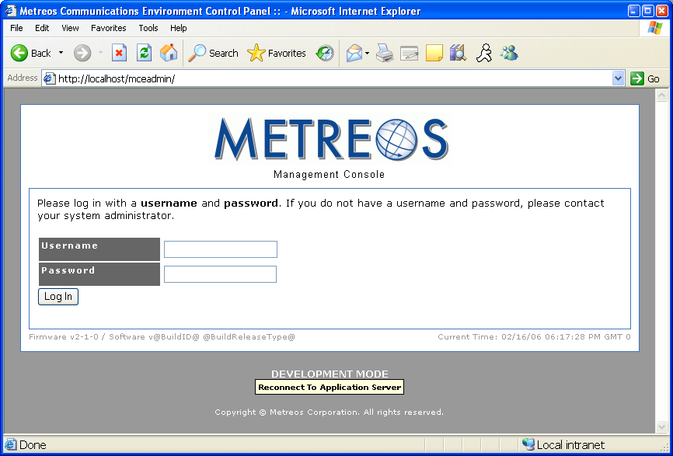

The Main Page appears, which is the portal into all system control of the MCE.

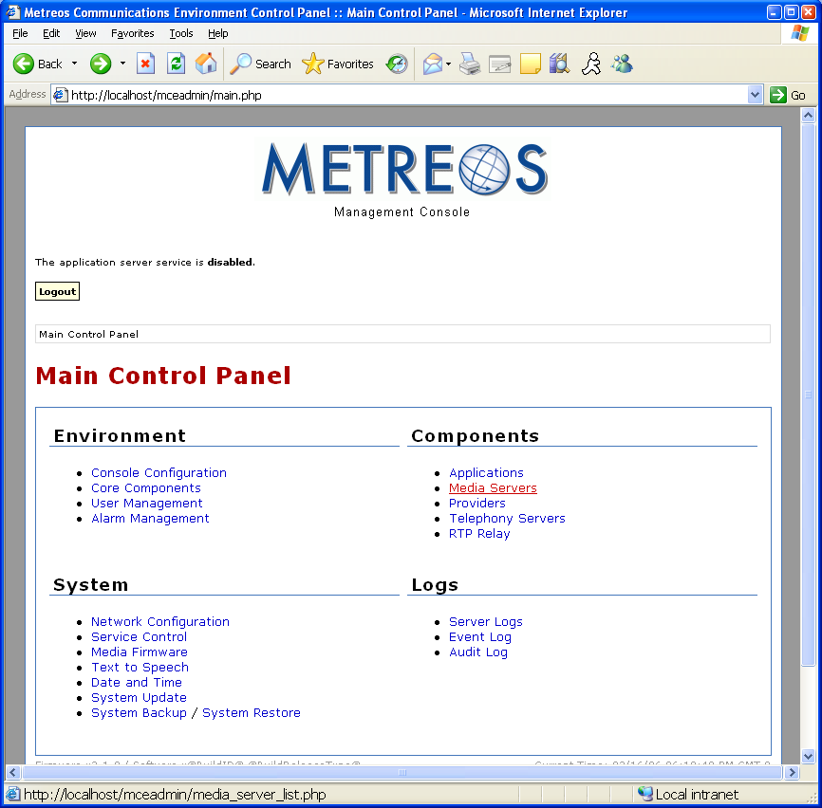

Check that a Metreos Media Server is associated with this server node. To do so, first navigate to the Media Servers link (mceadmin > Media Server). The Media Servers page appears. Here one can view existing, configured Media Servers, or add new media servers. If no media servers are listed, add a Media Server, by entering a descriptive Name and IP Address. Select Done when finished. The IP address should be ‘127.0.0.1’.

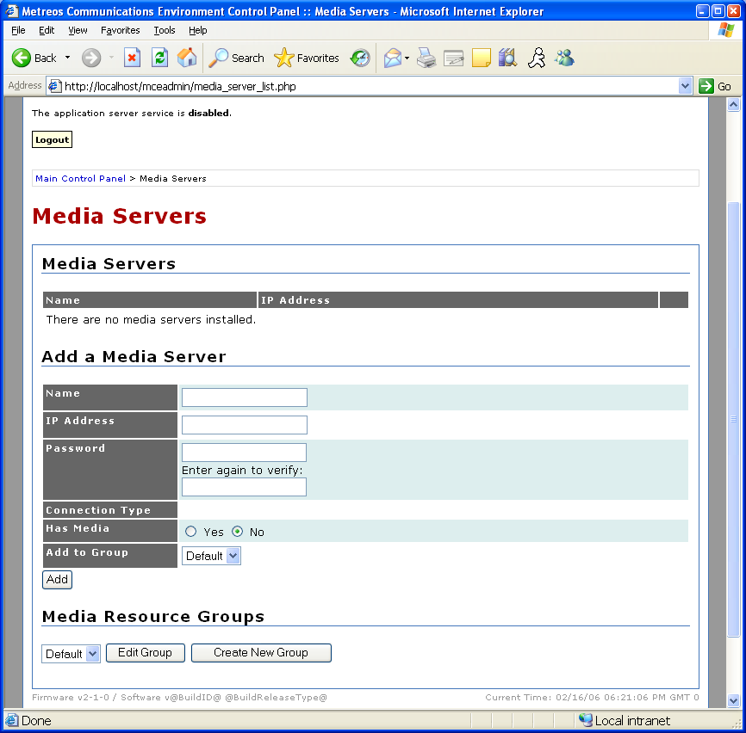

Assumption: this Metreos Communication Environment will only send calls and receive calls from CallManager. (This is not a limitation of the system; just defining the scope of this document)

The Metreos Communications Environment be ‘synchronized’ with information about your CallManager cluster. To do so, navigate to mceadmin > Telephony Servers. By adding new ‘Telephony Servers’ into the mceadmin database, you are letting the MCE system know about remote IP endpoints, such as CallManager, which can send and receive calls.

In the 2.1.4 release there are two types of Telephony Servers, ‘H.323 Gateway’, and ‘CallManager’. If one wants to leverage CallManager-specific capabilities, such as DeviceListX, CTI/JTAPI, and/or SCCP, a CallManager Telephony Server must be created. Realistically, this determination is made by understanding how each application installed on the MCE works, and what protocols are needed for each. If one wants to leverage on standards-based protocol, such as H.323, an H.323 gateway will need to be created, which in practice will point to a CallManager subscriber node.

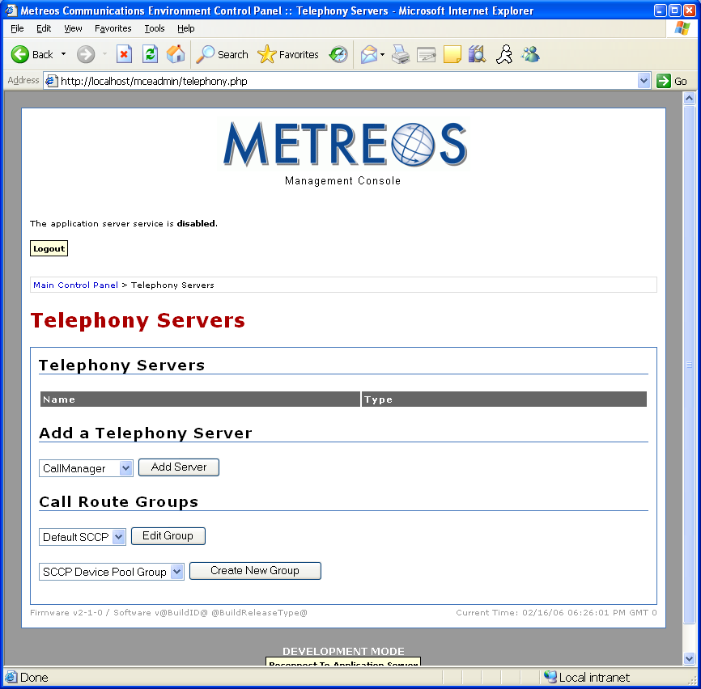

In this example, let’s assume that a 2 node (1 pub and 1 sub) CallManager will be defined in the MCE. The publisher is not currently configured to process calls. The publisher IP will be 9.45.89.80, and the subs will be 9.45.89.81 and 9.45.89.82.

For applications which need to leverage H.323 to make calls, we will need to define an H.323 gateway—in this case, with an IP address of 9.45.89.82. That way, applications such as VoiceTunnel, ActiveRelay, Click-To-Talk, and RapidRecord, which use H.323 to make H.323 calls, will have a CallManager H.323 endpoint that they can use to make those calls. (Those applications do not absolutely have to use H.323 to make calls, but it is what Metreos recommends).

To add an H.323 Gateway Telephony Server, navigate to mceadmin > Telephony Servers > Add a Telephony Server > Dropdown=H.323 Gateway > Add Server. Enter a descriptive name for the Name, and the IP address of a CallManager node processing calls (9.45.89.81, in this example). Note that the Add To Group drop down is set, by default, to Default H.323. Call Route Groups are applied to applications, and are used to determine what protocol and endpoint(s) are used to place calls. After this step, the Default H.323 call route group has one gateway in it, and can successfully be used for applications later.

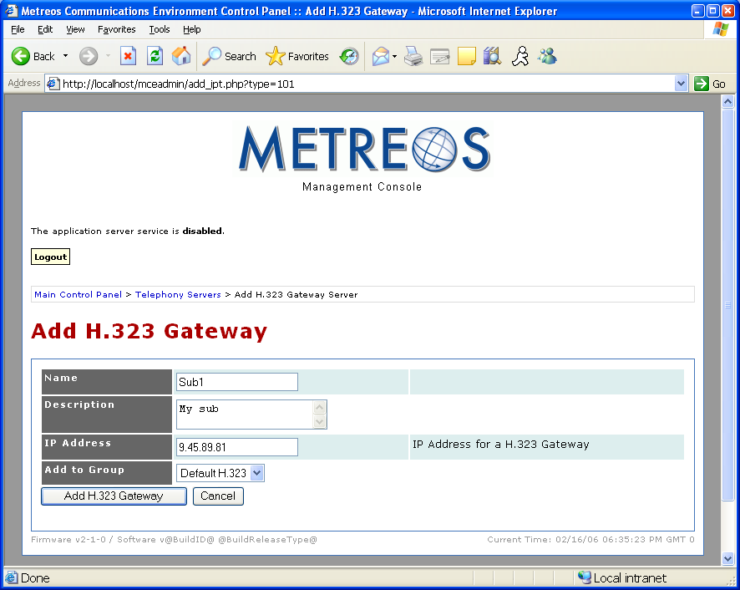
Now to define a CallManager cluster, so we can use CallManager-specific protocols. Of the applications installed on this server, only ActiveRelay realistically has a compelling reason to use such a protocol. Later we will use a shared-line configuration with a virtual MCE SCC phone and a user’s real IP phone to enable their account for ActiveRelay. So by defining the CallManager Telephony Server, we can also define a virtual SCCP Phone.

To add a CallManager Telephony Server, navigate to mceadmin > Telephony Server > Add a Telephony Server > Dropdown = CallManager > Add Server.

In this example, we define Name to a descriptive name, Version to 4.1, Publisher IP to 9.45.89.80, and the username/password to an OS username/password (user/pass is strictly for DeviceListX support—which is critical for Intercom, RapidRecord, and Click-To-Talk).

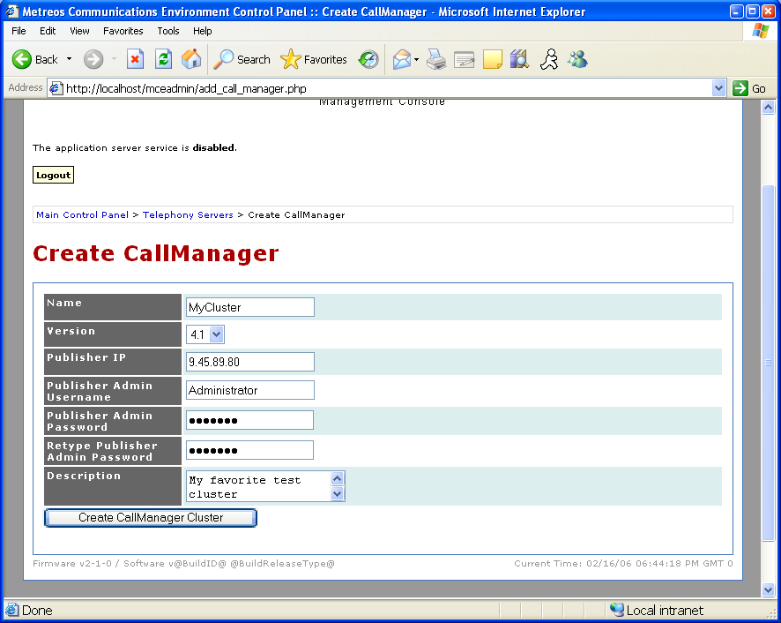
Once we’ve defined the CallManager publisher node, we can further define subscriber nodes with which to leverage SCCP or CTI. In this case, we want to define ‘SCCP Subscribers’, or in other words, CallManager subscriber nodes that the MCE will actually register virtual SCCP phones too. During this phase, the MCe is still being ‘synchronized’ to the information about your cluster.

To add a SCCP subscriber node to the MCE database, navigate to mceadmin > Telephony Server > MyCluster > SCCP Subscribers > Add Subscriber.

In this example, enter a descriptive Name, and an IP address of 9.45.89.81.

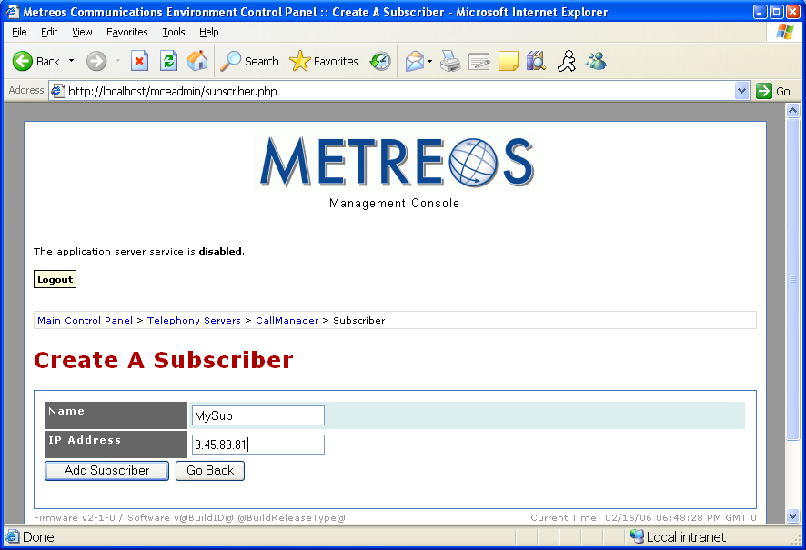

With a SCCP Subscriber defined, we can now define virtual SCCP devices, which are typically created in bulk and termed SCCP Device Pools in the MCE.

To add a SCCP device pool, navigate to mceadmin > Telephony Servers > MyCluster > SCCP Device Pools > Create SCCP Device Pool.

In this document, we will only show how to setup one ActiveRelay user. So strictly speaking, we only need one virtual SCCP device. With this guidelines, enter a descriptive Name, How many devices to register? = 1, and as the 6-Digit MAC address prefix, just enter something reasonably unusual such that it wouldn’t clash with a real IP phone, such as FFFFFF. With these values chosen, we can hit Create Device Pool. NOTE: this device pool is not in any way a CallManager device pool.

Once the Create Device pool button is hit, the MCE will immediately begin attempting to register to 9.45.89.81 (our SCCP Subscriber). If auto-registration is on, one can pretty much immediately find the device ‘SEPFFFFFF000000’ in the CallManager administrative pages, ccmadmin. Later we will modify this device to be in a shared-line configuration with a user’s phone.

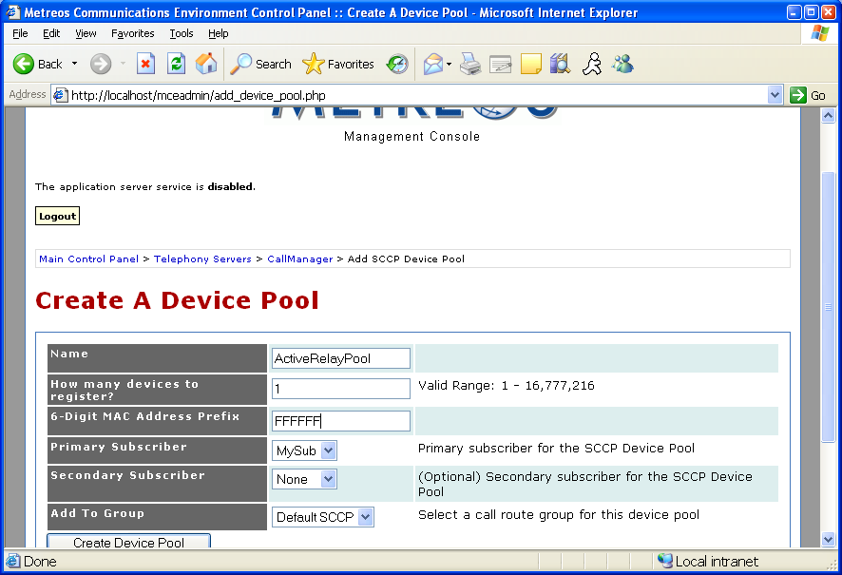

That concludes configuring the system. Still to do is configuring CallManager, and create a few test users, and configure the applications.

Configuring CallManager

As said before, some of the Metreos applications will be using H.323 to communicate. So one thing we need to do is to define an H.323 gateway in CallManager that corresponds to the Metreos server.
To create the Metreos H.323 Gateway in CallManager, navigate to ccmadmin > Device > Gateway > Add a New Gateway. Choose Gateway Type H.323—H.225 in the Device Protocol dropdown will be chosen automatically and is correct.

DeviceName = IP address of the MCE
CallingSearchSpace = Anything such that calls coming from our server will reach its destination.
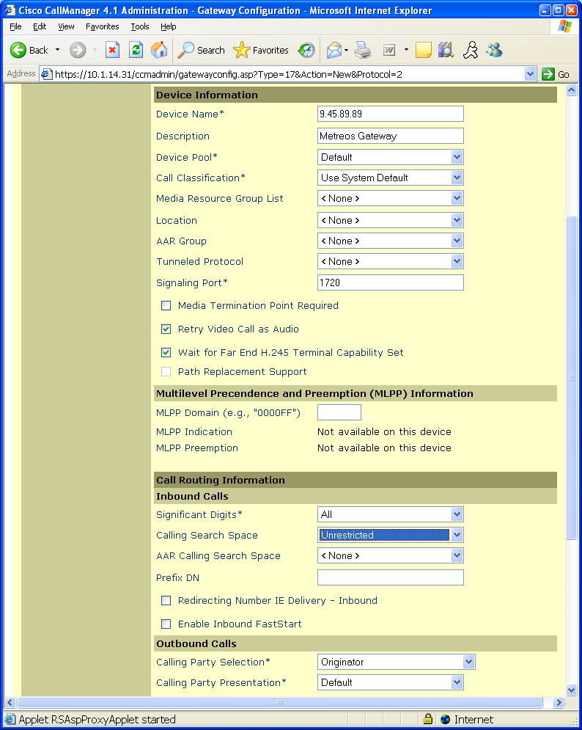
Some applications, such as VoiceTunnel, RapidRecord, ScheduledConference, Click-To-Talk, will use this H.323 gateway to inbound calls. To make this possible from a routing perspective, a route pattern needs to be made.

To create a route pattern, navigate to ccmadmin > Route/Hunt > Route Pattern > Add a New Route Pattern.

For this example, we will assume that 60000-60009 are not being used for directory numbers or other patterns. Most importantly, make the pattern generic enough to give Metreos applications ‘room’ to route on particular numbers, which we will configure later on the applications in mceadmin. In this example, we use the pattern 6000X, giving us 10 unique DIDs—more than enough for a standard demo installation.

Route Pattern = 6000X
Partition = Anything that allows test phones to reach this pattern
Gateway/Route List = MCE IP

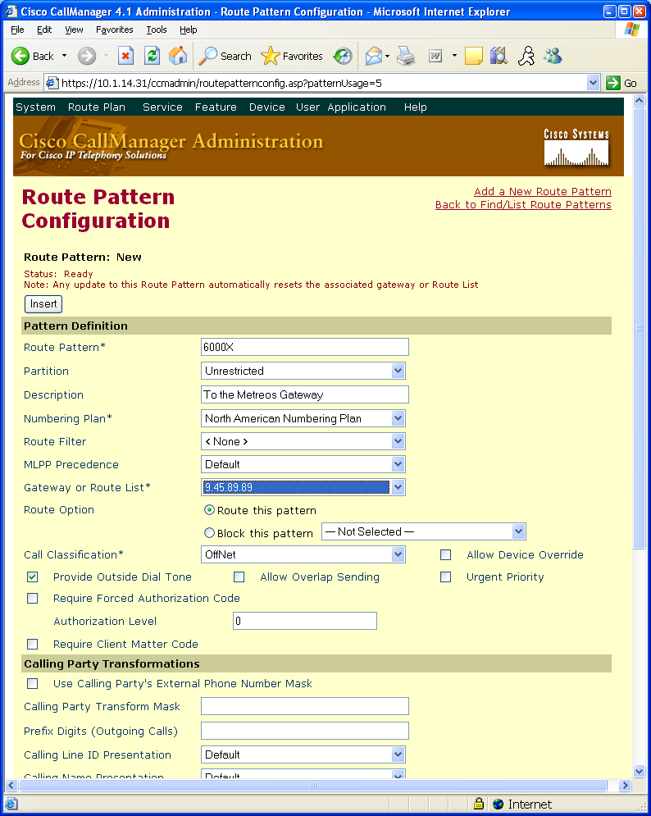
For an easy demonstration of RapidRecord, create a route pattern with a very unique prepend… ideally 99999 followed by the number of X’s to represent your dial plan for IP phones. In the case you use 5 digit dialing, create a 99999XXXX pattern which routes to the H.323 gateway of the MCE

Route Pattern = 99999XXXX
Partition = Anything that allows test phones to reach this pattern
Gateway/Route List = MCE IP

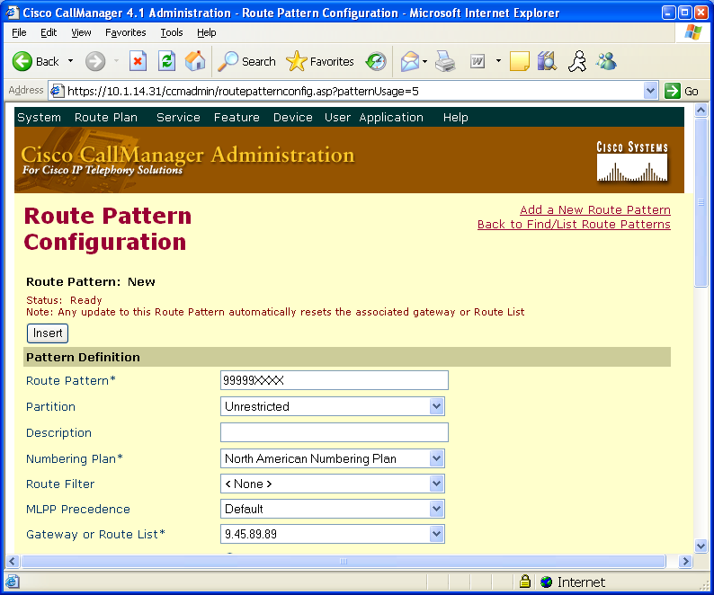
Some applications use Cisco IP Phone Services, such as ActiveRelay and Intercom.

To create the ActiveRelay service, navigate to Feature > Cisco IP Phone Services > Add a New IP Phone Service.

Service Name: Metreos ActiveRelay
Description: Swap call from Find Me number to office phone
Service URL: http://MCE_IP:8000/ActiveRelay?device=#DEVICENAME#

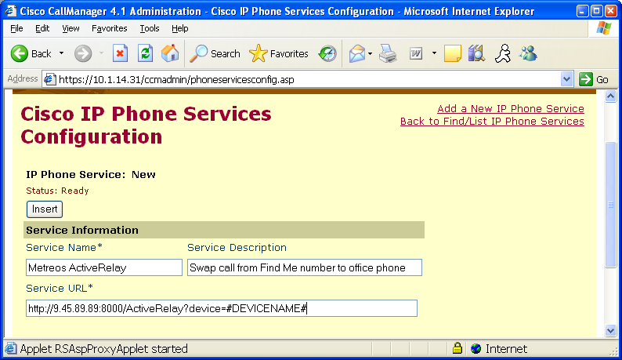

To create the Intercom service, navigate to Feature > Cisco IP Phone Services > Add a New IP Phone Service

Service Name: Metreos Intercom
Description: Creates instant conferences with predefined groups
Service URL: http://MCE_IP:8000/ShowIntercomGroups?device=#DEVICENAME#

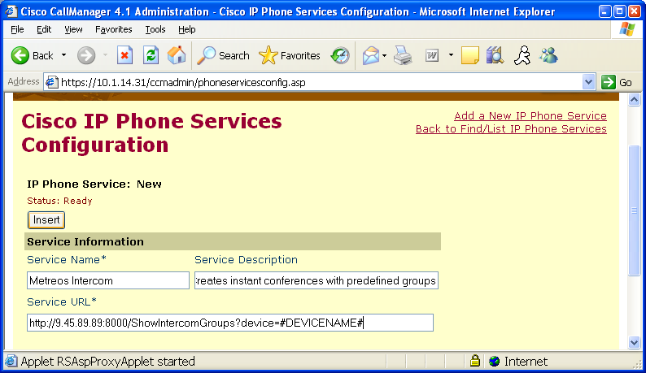
For any user’s IP phone that will be enabled with the ActiveRelay application, ideally the ActiveRelay Cisco IP Phone service would be associated with it so the swap feature can be demonstrated.

To associate a device with a Cisco IP Phone Service, Devices > Phones > (Find user phone) > Subscribe/Unsubscribe Services > Choose ActiveRelay Service > Continue > Subscribe.
Note that the SEP000011110000 phone is being enabled for ActiveRelay in this example—so it should have the AR service.

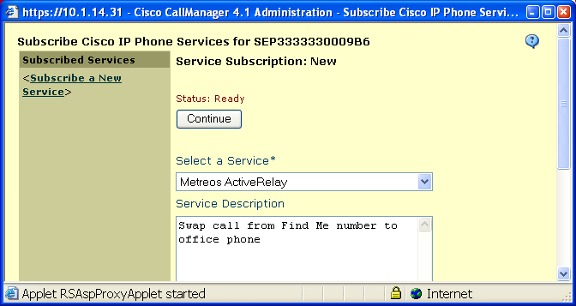

For any user’s IP phone that will be allowed to initiate and host an Intercom conference, the Intercom Cisco IP Phone Service must be associated with it.

To associate a device with a Cisco IP Phone Service, Devices > Phones > (Find user phone) > Subscribe/Unsubscribe Services > Choose Intercom Service > Continue > Subscribe.

In this demo, SEP000011110000, SEP000022220000, and SEP000033330000 will all be put into an Intercom group, so they could all feasibly have the Intercom group associated with them so they can initiate the intercom conference.
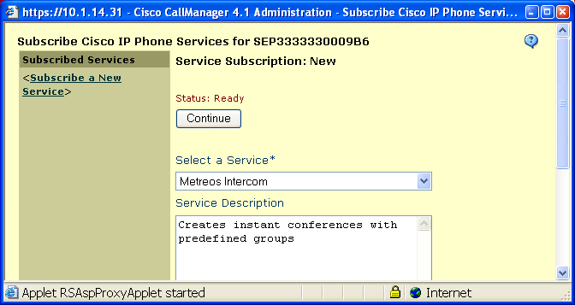
Some Metreos applications will attempt to send IP Phone XML commands directly to an IP Phone. A requirement when sending an XML command is to pass username/password credentials corresponding to a CallManager user associated with that phone. By default, these Metreos applications will send the username/password = metreos/metreos.

The applications which use IP Phone XML commands are Intercom, Click-To-Talk, and RapidRecord. So, every user/phone that will possibly be in an intercom group should have the metreos user associated with it, and every user user/device that will be used to demo Click-To-Talk should have the metreos user associated with it. Also, any phone that a user account with recording enabled should also have the metreos user associated with it.
To create the metreos user, navigate to User > Add a New User.

The only critical fields are User ID = metreos, and User Password = metreos.

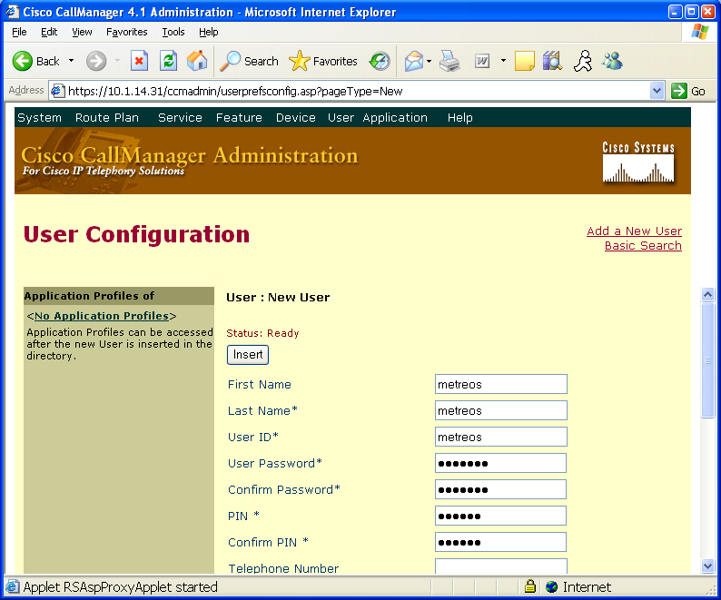
To associate the metreos user with a phone or group of phones, navigate to User > Global Directory > Find and select the metreos user > Device Association > Select phones to associate

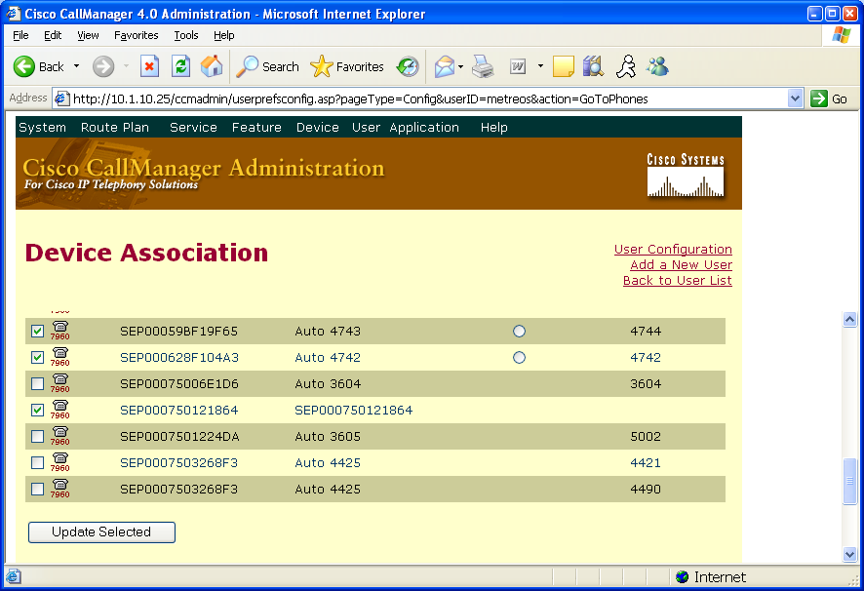
To demonstrate setting up one ActiveRelay user in a shared-line configuration, we will need to create one SCCP phone, which will later be hosted by the Metreos server.

To create a 7960 SCCP phone, navigate to Device > Phone > Add a New Phone > Phone Type = Cisco 7960
Mac Address = FFFFFF000000

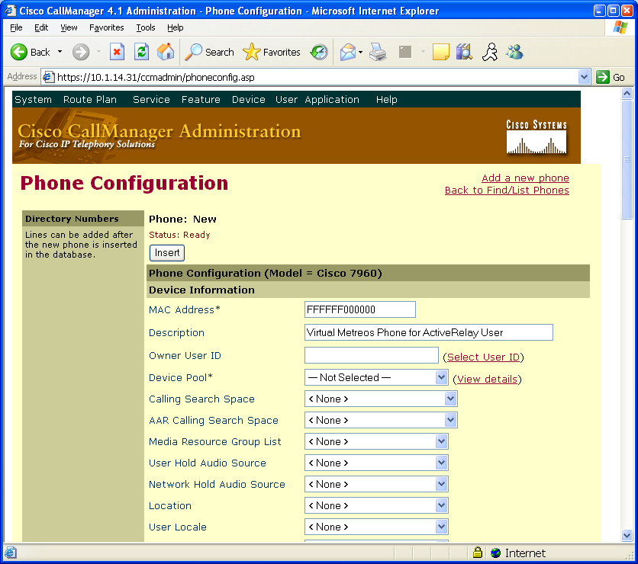
Add a directory number to the new SCCP phone—but make sure it is a shared line with a real IP phone that you will be able to demo ActiveRelay with. Later we will make a user account with the real IP phone associated with it, so keep that in mind.
Once the line is shared in ccmadmin, you are done configuring the virtual device. Be sure not to change any settings on the shared line, because it will affect the user’s real IP phone line as well.

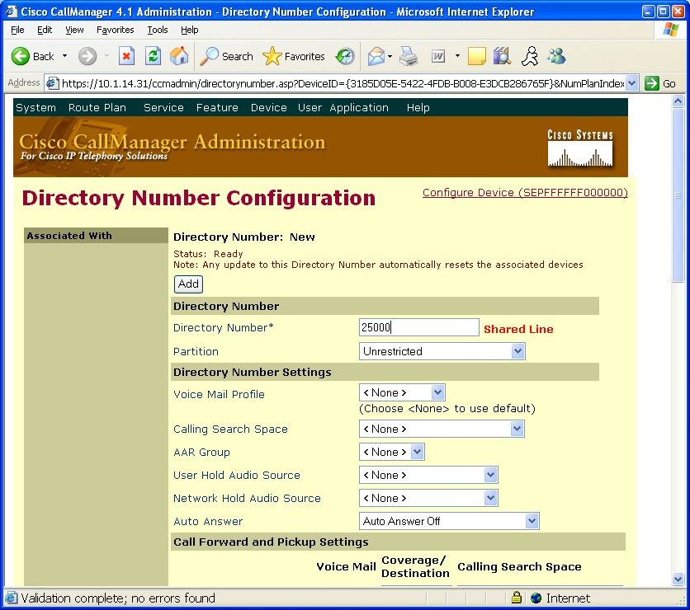
Now that we have enough configured in ccmadmin to support every application, we can now finish configuring the Metreos platform.

We will need to configure the 6 standard Application Suite applications. Starting with the trigger criteria for ActiveRelay, navigate to mceadmin > Applications > ActiveRelay > Edit Default Partition > Edit Trigger Parameters for the IncomingCall script > Add Trigger Parameter

Based on the shared-line extension created in the previous step, enter the ‘to’ condition to trigger ActiveRelay:

Parameter Name = to
Initial Value = 25000

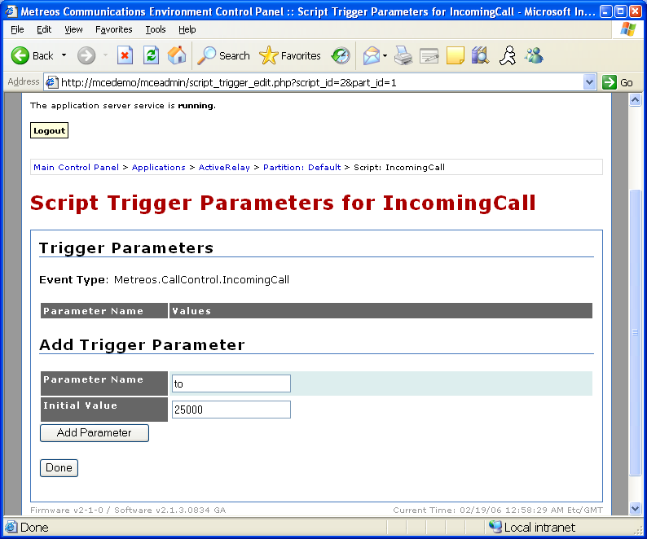
Click-2-Talk configuration requires that we enter some information in the application configuration page. Navigate to mceadmin > Applications > ClickToTalk.

The SMTP configuration is optional--when a recorded ClickToTalk call ends, an email with a link or attachment is sent to the user’s account. ClickToTalk can still be demoed without the email piece.

SMTP_Server = IP or domain name of mail server
SMTP_Username = Username for mail server
SMTP_Password = Password for mail server
SMTP_FromAddress = a real account on the mail server
AppServerDN = 60002
AppServerIP = IP address of the MCE (say, 9.45.89.89)
RecordFileURL = http://9.45.89.89/media/

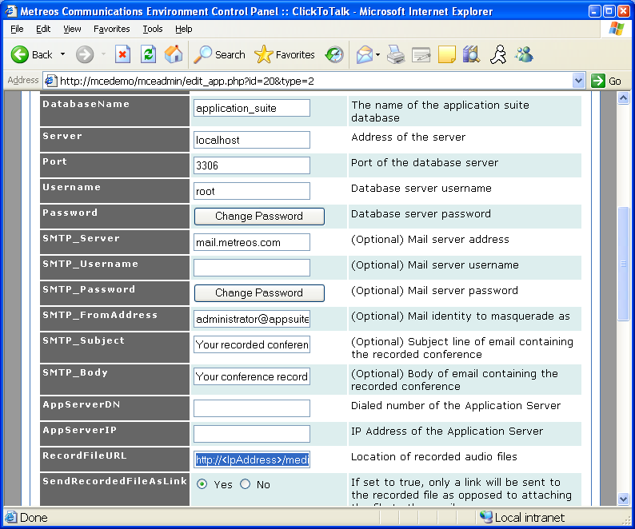
ClickToTalk also must have a trigger condition set. To do so, navigate to mceadmin > Applications > ClickToTalk > Edit Default Partition > Edit Trigger Parameters of AddCallToConference > Add Trigger Parameter >

Parameter Name = to
Initial Value = 60002

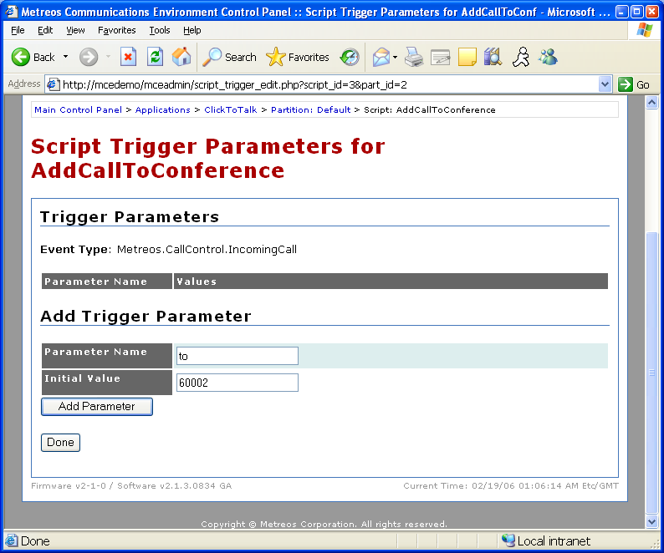
RapidRecord configuration requires that we enter some information in the application configuration page. Navigate to mceadmin > Applications > RapidRecord

Application Server IP = 9.45.89.89

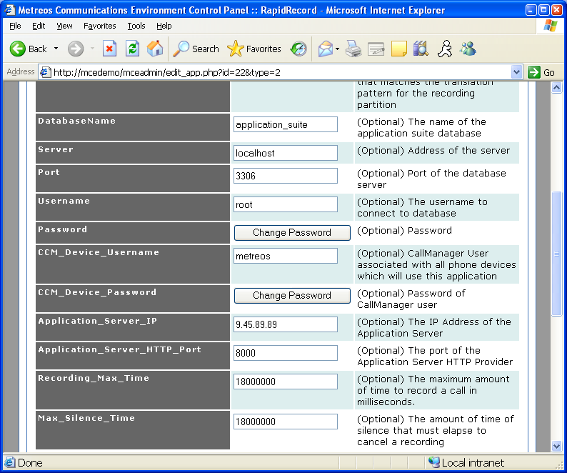
RapidRecord also must have a trigger condition set. To do so, navigate to mceadmin > Applications > RapidRecord > Edit Default Partition > Edit Trigger Parameters of Record > Add Trigger Parameter >

Parameter Name = to
Initial Value = regex:99999.+

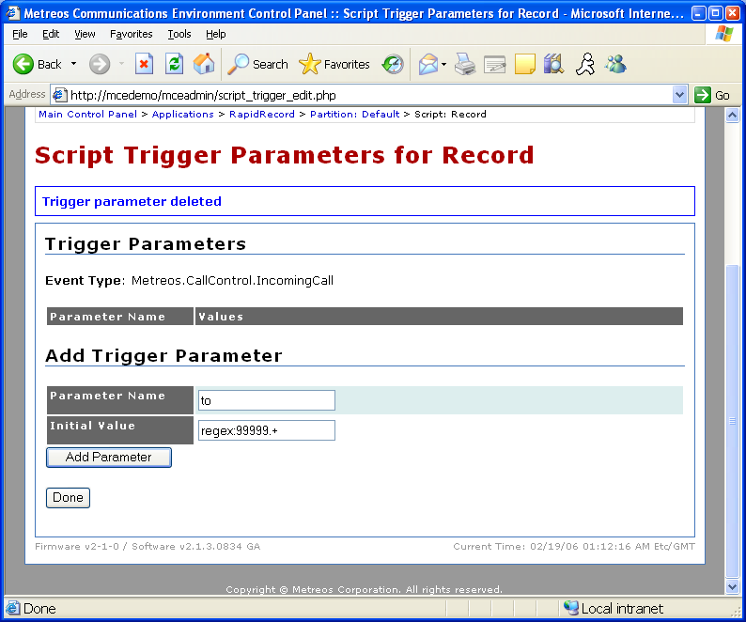
ScheduledConference must have a trigger condition set. To do so, navigate to mceadmin > Applications > ScheduledConference > Edit Default Partition > Edit Trigger Parameters of IncomingCall > Add Trigger Parameter

Parameter Name = to
Initial Value = 60001

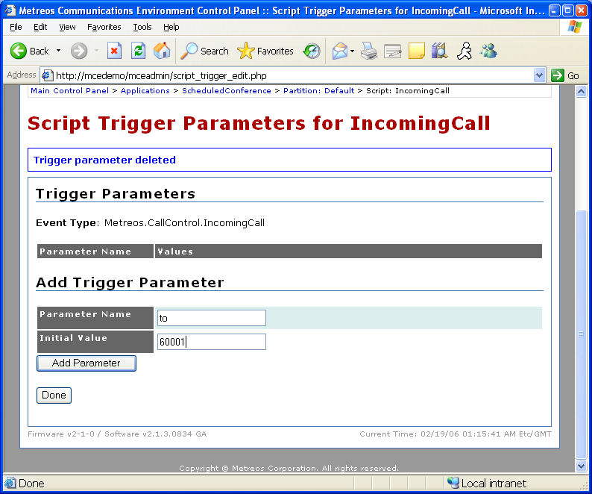
VoiceTunnel must have a trigger condition set. To do so, navigate to mceadmin > Applications > VoiceTunnel > Edit Default Partition > Edit Trigger Parameters of CallRouter > Add Trigger Parameter

Parameter Name = to
Initial Value = 60000

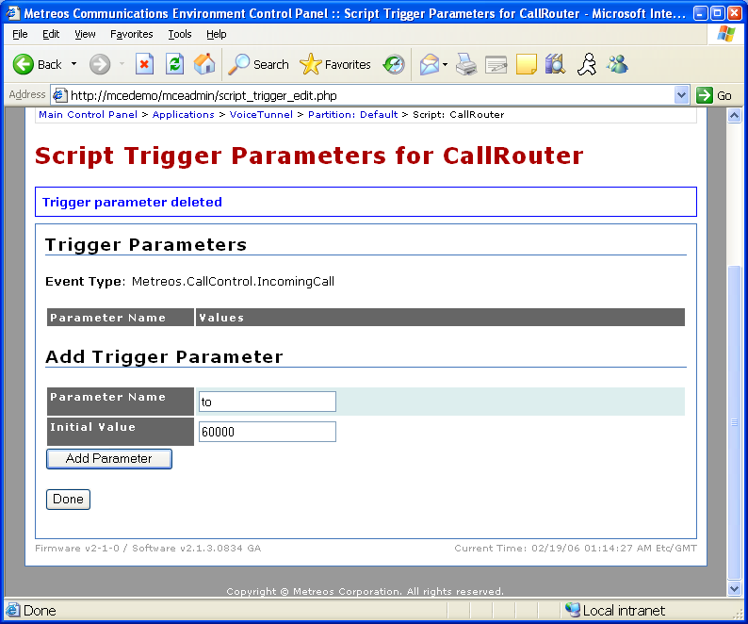
The last bit of configuration occurs in ‘appsuiteadmin’, or the Application Suite and User administrative site, found at http://MCE_IP/appsuiteadmin.

To log in, enter Administrator/metreos

For this demo setup, we will assume that 3 physical IP phones are present. One IP phone will be the same real IP phone we created a shared line appearance with from up above with ActiveRelay.

For this example, let’s assume that the device names of the 3 phones are:
SEP000011110000 (primary extension = 25000)
SEP000022220000 (primary extension = 25001)
SEP000033330000 (primary extension = 25002)

SEP000011110000 = User 1 – enabled for ActiveRelay
SEP000022220000 = User 2
SEP000033330000 = User 3

And that we will make 3 users, with username ‘1’, ‘2’, and ‘3’, and will be associated with the devices in order as listed above.

To start, create user 1. Navigate to appsuiteadmin > Account Management > Create User, and enter ‘1’ in every field shown, except email—enter 1@metreos.com (it doesn’t matter, but it will validate email address to make sure it’s formatted correctly). Also, for lockout threshold, enter ‘10’ (this allows someone demoing to mess-up on the login up to 10 times in a row before locking the account). Select Create User when done.

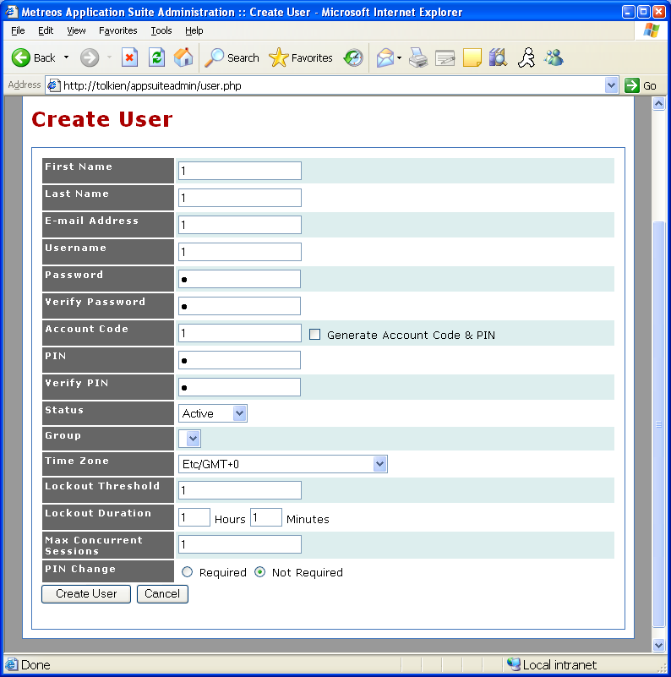
For this example, let’s make this the account which has ActiveRelay enabled. So, scroll down to the Devices section, and enter a device for the user, corresponding to the MAC and line number of the physical IP phone of the user. This real IP phone must have a shared-line configuration with the virtual SCCP Phone created before for ActiveRelay to initiate when this user’s phone is dialed.

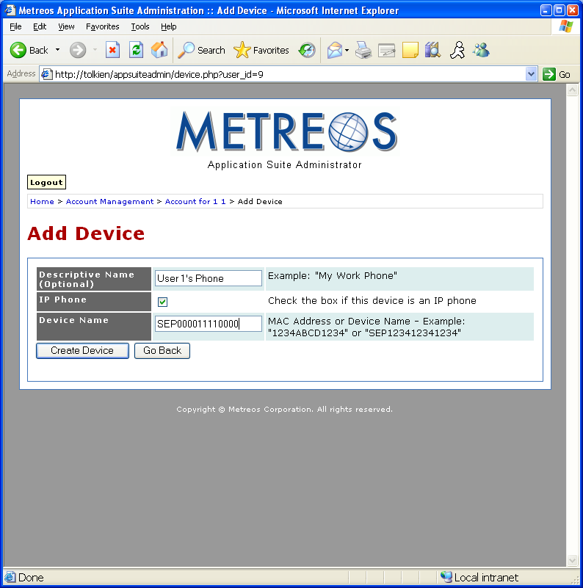
On the new device just created, also enter the real extension as the line number on this device, in this example ‘25000’.

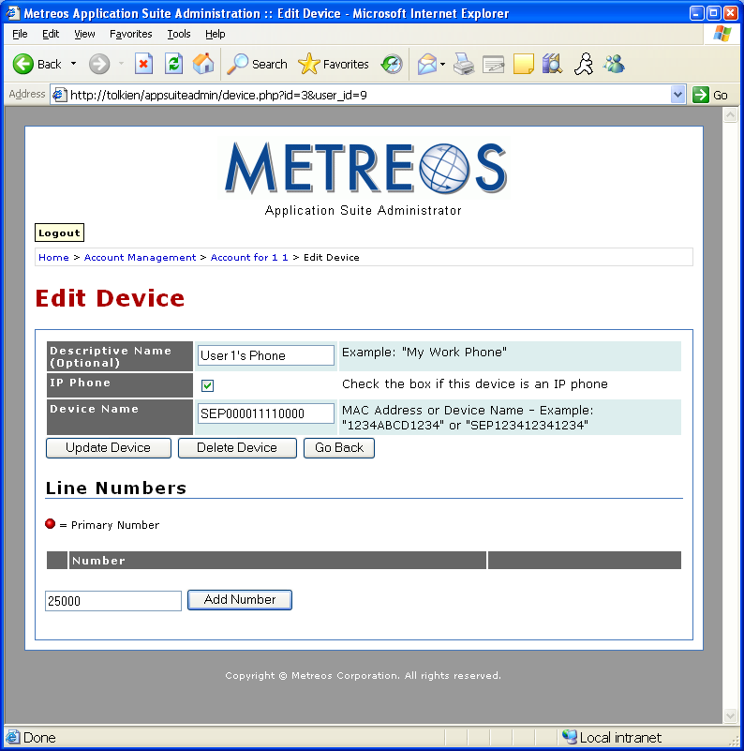
For ActiveRelay to do something interesting when the user’s phone is called at 25000, we will need to define and enable at least one Find Me number. Define one by going to the Find Me Numbers section on the user account 1.
For the new Find Me number, set the following parameters:

Name = Descriptive name of the Find Me number
Phone Number = a number to demonstrate as the user’s Find Me number. If you want to demo your cell phone, for instance, 91XXXXXXXXXXX is probably the correct format for your phone number. Use no punctuation. You can enter an IP Phone number too, if PSTN access is not available.
Delay Call Time = 0
Call Attempt Timeout = 0
Enable ActiveRelay = CHECKED
Time Of Day = Leave alone

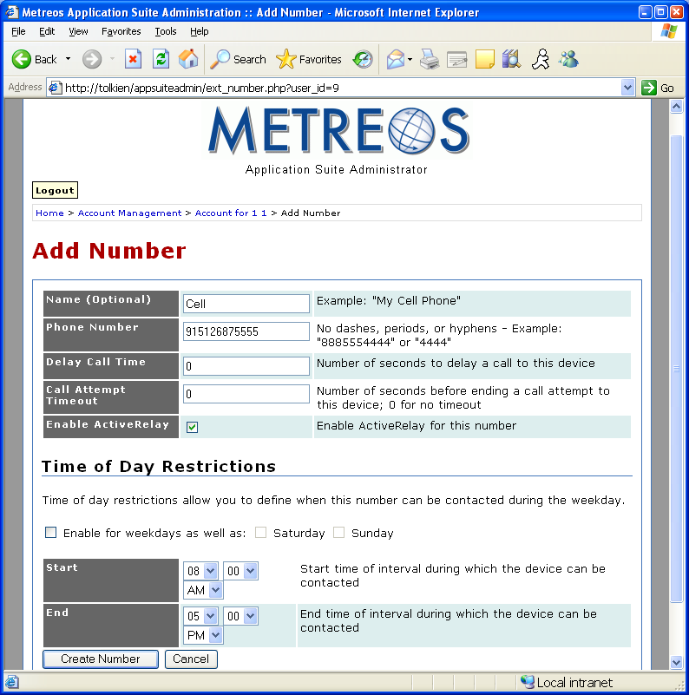
Of the 3 IP phones, we’ve already created an account for the ActiveRelay-enabled one. The next two accounts, and their corresponding devices, will be used primarily for demonstrating Intercom.

Create the next two accounts as we did with account 1.

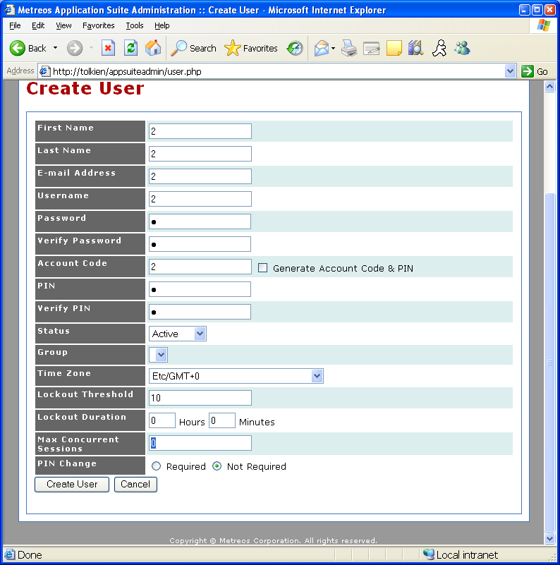
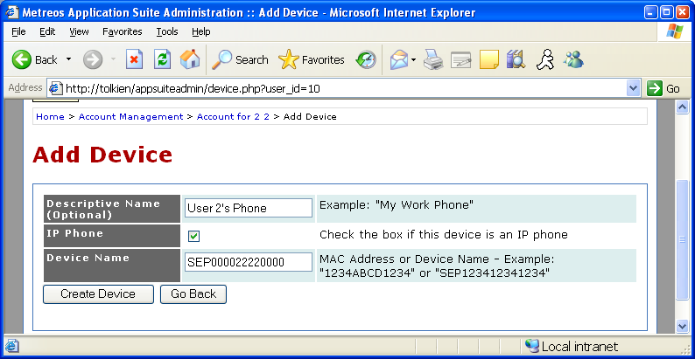
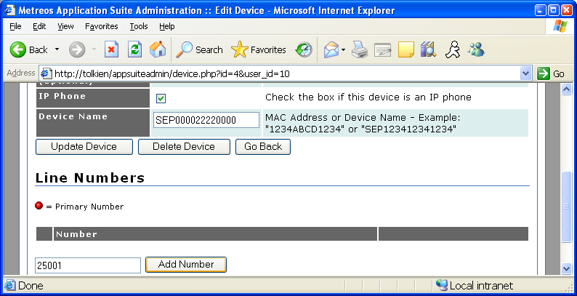
And User 3…
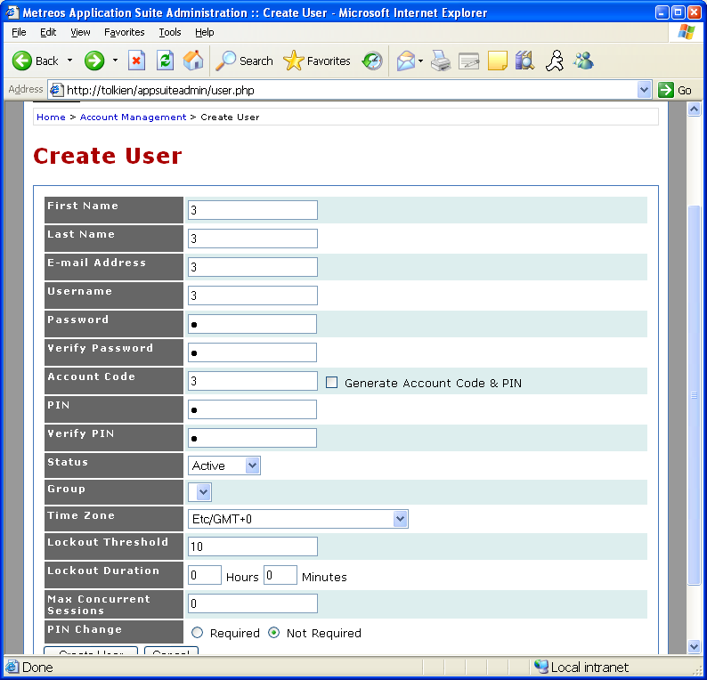
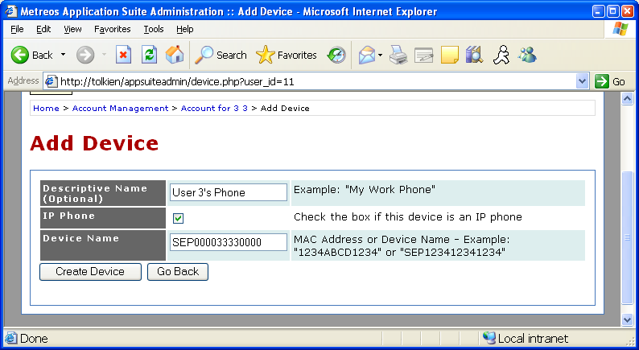
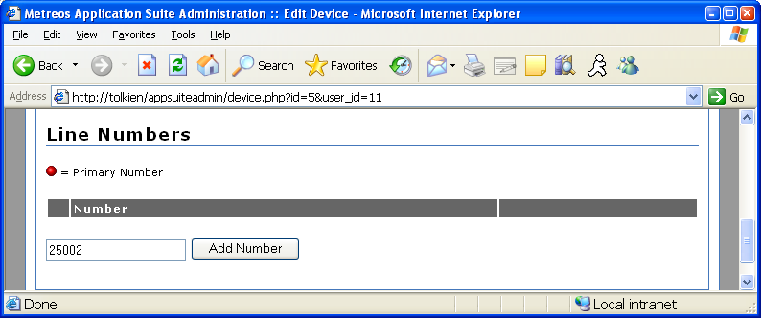
To demonstrate Intercom, you’ll need to make at least one Intercom Group. We can easily make a group with all 3 users by navigating to appsuiteadmin > Intercom > Create Group

Name = Descriptive Name
Enabled = CHECKED
Talkback Enabled = CHECKED
Private = Unchecked (not really that important for demoing—just means end-users can’t join themselves to this group)

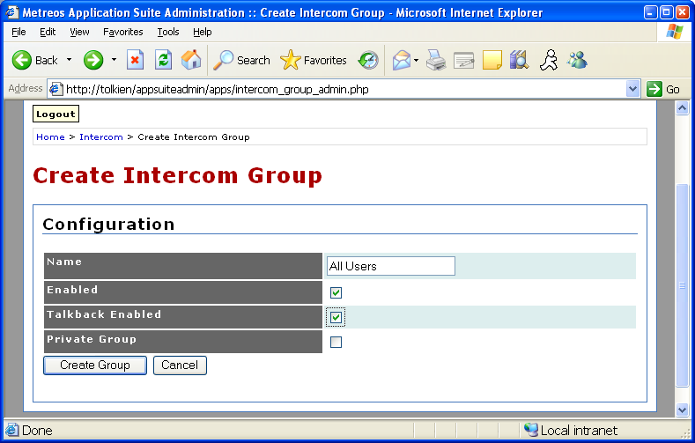

Add the three users to the intercom group by entering their username to the Add User by Username field for each user.

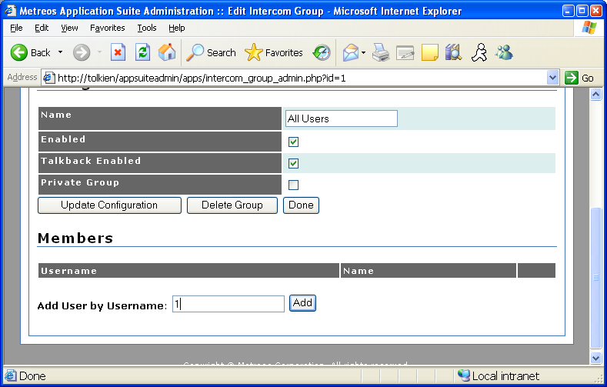
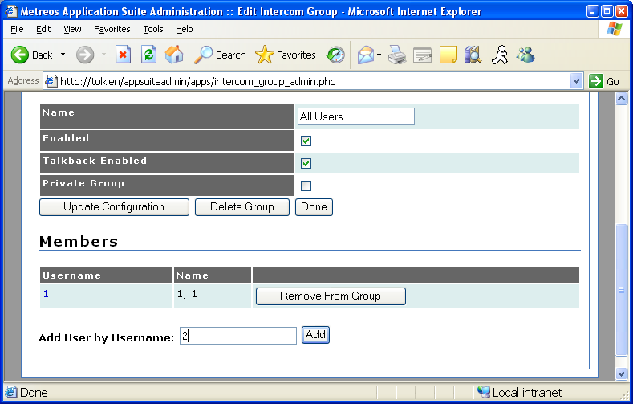
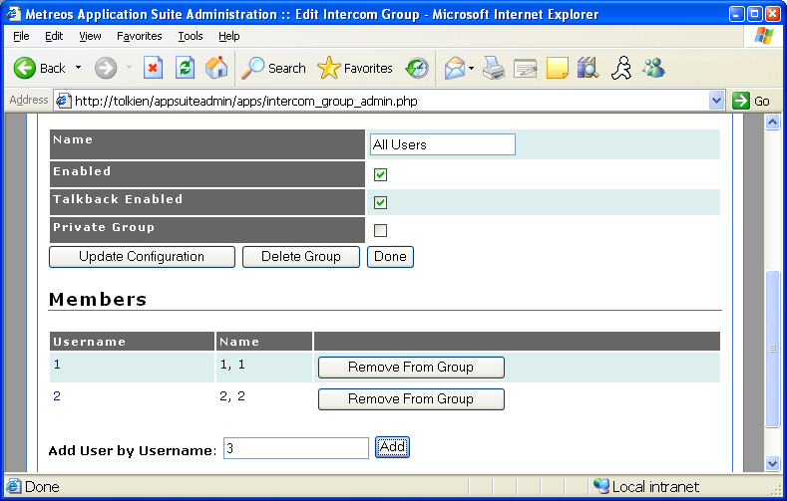

You should now be able to demonstrate all applications.

VoiceTunnel:
Dial 60000
Enter an account code#/pin# combination at the prompts. (1#1#, 2#2#, 3#3#, etc)
Enter a number to dial, followed by #.
With the call up with the other party, you can hit ### to hangup on the called party and dial again.

ScheduledConference:
Navigate to appsuiteadmin > Scheduled Conference > Create Conference
Note the host pin and participant pin after creating the conference—either pin will work to get into the conference (today both pins have the same effect)
Dial 60001
Enter host or participant pin
Ideally, dial 60001 and enter pin with another pin to show conferencing.

ClickToTalk:
Install C2T plugin into Outlook. Enter settings. Open contact list. Shift click to add participants. Hit Metreos Globe to call.

RapidRecord:
Dial 99999 plus the actual extension to dial. Note that this may seem odd—there is a way to configure the dial plan of a phone such that the user never dials 99999 to initiate a recoded call. However, a few changes must be made to the dial plan of the phone. So, to make RapidRecord easy to demo, just dial 99999 and the extension to get a call through RapidRecord. Note that the RapidRecord IP Phone control panel won’t show up on a phone unless there is an account associated with the device in appsuiteadmin.

Intercom:
Cisco IP Phone Service driven application—
Have a service subscribed to the phone you wish to initiate the conference, AND
Have the phone hosting the intercom group have an associated account in appsuiteadmin, and should be a part of an intercom group.

For instance, SEP00011110000 in this example should have the Intercom service subscribed, and could then kick off the ‘All Users’ intercom group made in this example

ActiveRelay:
Call the ActiveRelay-enabled phone/account. The Find Me number should ring shortly thereafter (note that if you are demoing a cell phone as the Find Me number, there is usually about 3-5 second delay before the cell will ring).

Pick up the Find Me number, and hit ‘#’ to confirm the call. Note that during the call you can push ** to transfer the call to a number configured as the ActiveRelay Transfer Number on the account being demoeed. Also, if the AR service is on the user’s demo phone, you can demonstrate the ‘Swap’ feature, which swaps a call from Find Me number to office phone.
Note that at least one of the 3 user accounts should have the Record Call and Recordings Visible checkbox CHECKED in order to make an interesting demonstration possible. The account(s) which have recording enabled should be dialed with the 99999XXXX route pattern to route the call through the MCE, to give RapidRecord a chance to record the call bound to the user device.

